Assignment 30 : Chat Groq RAG application using Streamlit UI

Github Repositary link : https://github.com/ash-iiiiish/Chat-Groq-RAG-Application

Demo images :
Code images :
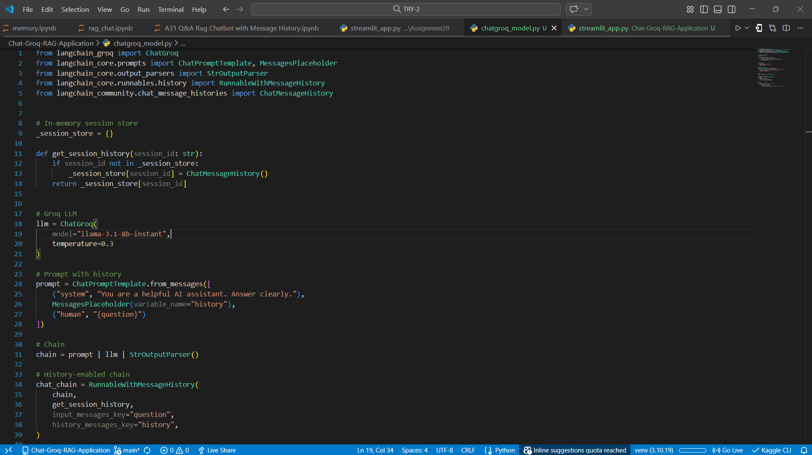

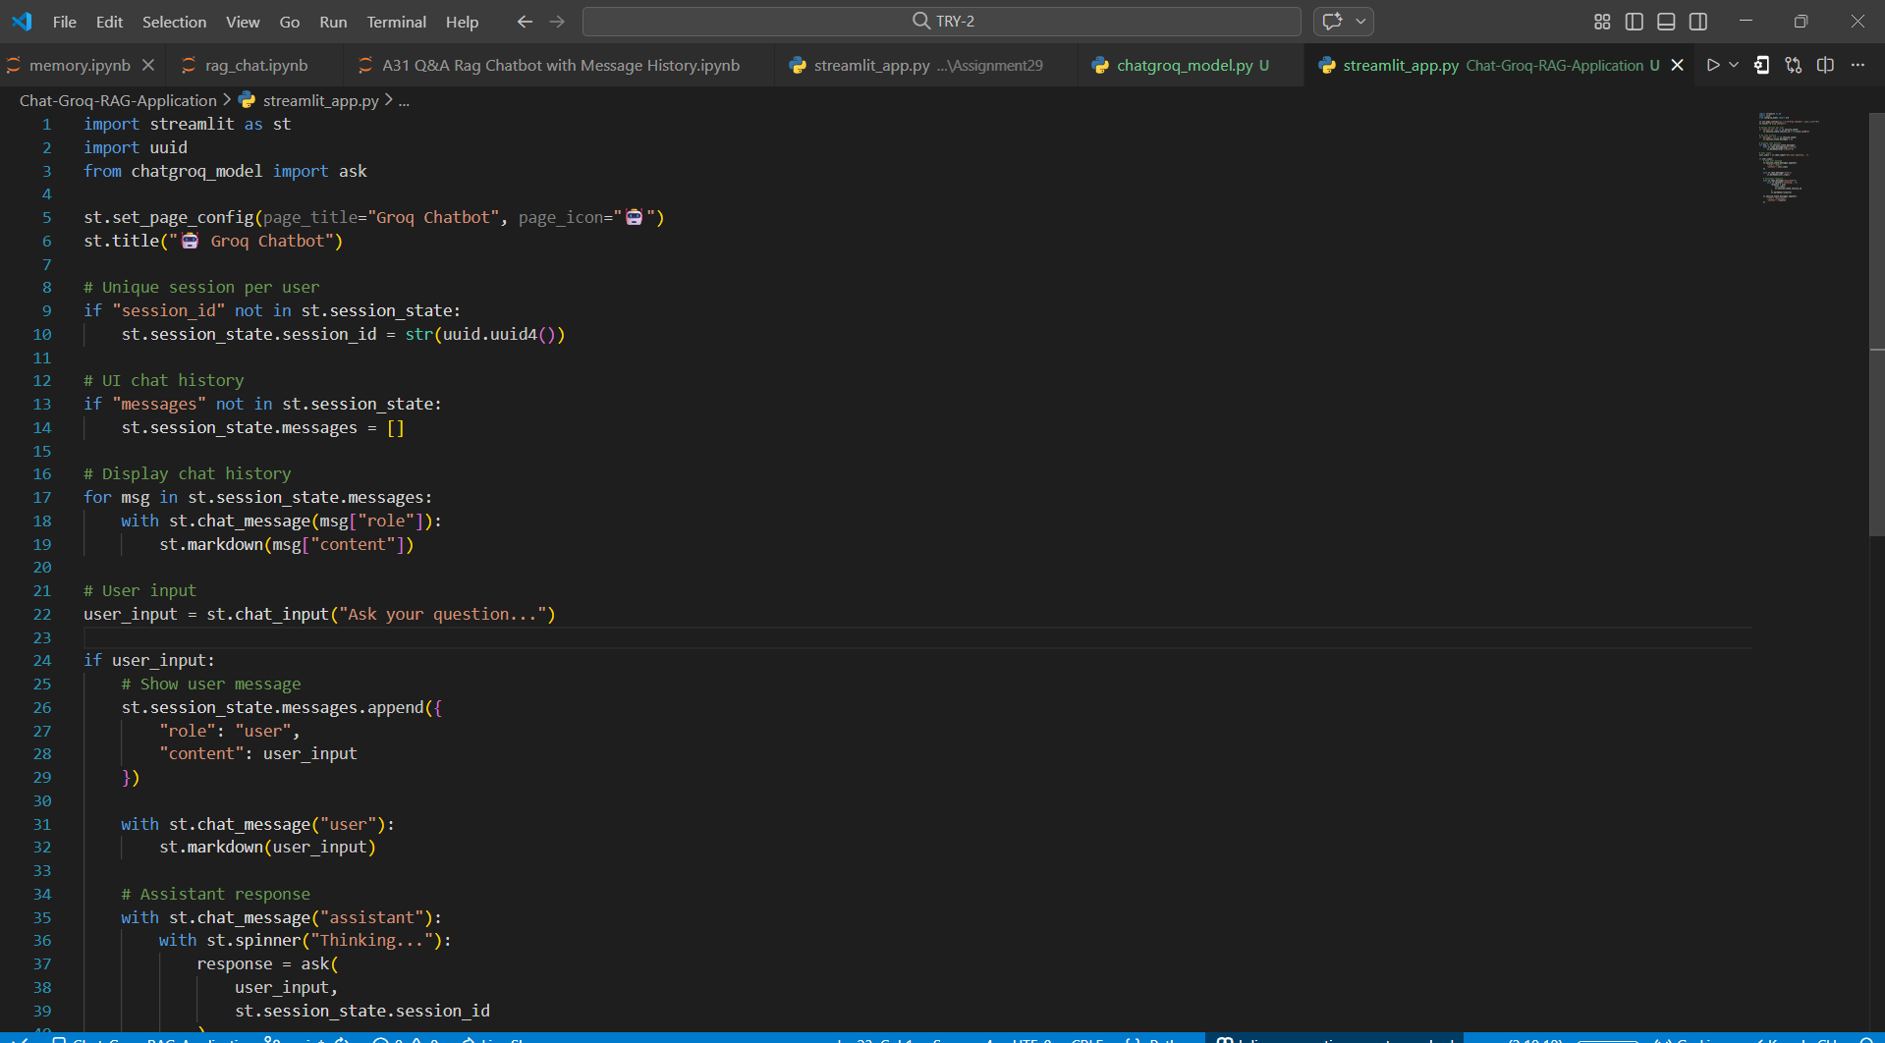

Demo of working!

